Statistics 23, Section 1, Midterm I
Tuesday, September 21, 1999

Name: _______Solution________________________________________

Pledge: I have neither given nor received aid on this examination.

Signature: _____________________________________________________

Instructions: Show all work, but do not do hard arithmetic (an answer of the form $\left(\begin{matrix}8 \\ 3\end{matrix}\right)⋅3^{7}$is fine).

- A company makes 50% of its cars at Factory A, 30% at Factory B and the rest at Factory C. Factory A produces 10% lemons, Factory B produces 15% lemons, and Factory C produces 20% lemons. If a car is randomly selected for the overall production system,

- What is the probability that it is a lemon?
[8]
P{A} = 0.5, P{B} = 0.3, P{C} = 0.2, P{L|A} = 0.1, P{L|B} = .15, P{L|C} = 0.2

P{L} = P{(L and A) or (L and B) or (L and C)} = P{L & A} + P{L & B} + P{L & C}

= P{L|A} P{A} + P{L|B} P{B} + P{L|C} P{C}

= (0.1) (0.5) + (0.15) (0.3) + (0.2) (0.2) = 0.05 + 0.045 + 0.04 = 0.135

- If it turns out to be a lemon, then what is the probability that it was built at Factory C?
[7]
P{C|L} = P(C and L} / P{L} = P{L|C} P{C} / P{L} = (0.2) (0.2) / 0.135

Or use Bayes rule:

P{C|L} = P{L|C} P{C} .
P{L|A} P{A} + P{L|B} P{B} + P{L|C} P{C}
= (0.2) (0.2) .
(0.1) (0.5) + (0.15) (0.3) + (0.2) (0.2)
- The IRS says about 5 in 1000 tax returns with income below $50,000 are audited, as are 10 in 1000 for income between $50,000 and $99,999, and 25 in 1000 for income $100,000 and more. P{A|Lo} = 0.005, P{A|mid} = 0.01, P{A|Hi} = 0.025.

- If 10 taxpayers are chosen at random from the high income group, write a (complete) formula that could be used in an Excel formula bar to calculate the probability that: X = # A, X~Bi(10, 0.025).

- Either none, or else at least 4 of them get audited.
[5]
P{X = 0 or X >= 4} = P{X = 0} + 1 – P{X <= 3} =

=BINOMDIST(0,10,0.025,FALSE) + 1 - BINOMDIST(3,10,0.025,TRUE)

- Exactly 2 of them gets audited, if it is known that at least 2 are audited.
[5]
P{X = 2|X >= 2} = P{(X = 2) and (X >= 2)} / P{X >= 2} = P{X = 2} / P{X >= 2} =

=BINOMDIST(2,10,0.025,FALSE)/(1-BINOMDIST(1,10,0.025,TRUE))

- Fill out the Excel menu below to calculate the probability that from a group of 15 taxpayers chosen randomly from the low income group, exactly one of them gets
[5] audited.
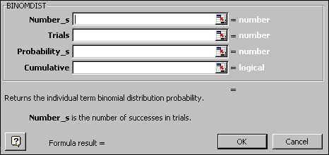
1 15 0.005 false
(c) If three taxpayers are randomly selected from the low income groups, and four are selected from the high income group, write a complete Excel formula to calculate the probability that none of these will be audited.
[5]
P{(none Lo) and (none Hi)} = P{none Lo} P{none Hi} =

=BINOMDIST(0,3,0.005,TRUE)*BINOMDIST(0,4,0.025,TRUE)
- Suppose events $A$, $B$ and $C$ all have probability 0.5, and $A$ and $B$are mutually exclusive, and $B$ and $C$ are independent.

- Find $P\left\{A \text{or} B\right\}$.
[5]
= P{A} + P{B} – P{A and B} = 0.5 + 0.5 – 0 = 1

- Find $P\left\{B \text{or} C\right\}$.
[5]
= P{B} + P{C} – P{ and C} = P{B} + P{C} – P{B and C} =

= 0.5 + 0.5 – (0.5) (0.5) = 0.75

4. The random variable $X$ has distribution:
x | 0 | 1 | 2 | 4
f(x) | 0.3 | 0.2 | 0.1 | 0.4

- Find $P\left\{1≤X<4\right\}$.
[5]
= f(1) + f(2) = 0.2 + 0.1 = 0.3

- Find $P\left\{X=4|X≥2\right\}$.
[5]
= P{(X = 4) and (X >= 2)} / P{X >= 2} = P{X = 4}/ P{X >= 2} =

= f(4) / [f(2) + f(4)] = 0.4 / (0.1 + 0.4) = 0.8

- Find $P\left\{X=4|X≤2\right\}$.
[5]
= P{(X = 4) and (X <= 2)} / P{X >= 2} = 0
5 The following table shows the numbers of adults from a small town in age income categories, entered into an Excel spreadsheet, for marketing research purposes.
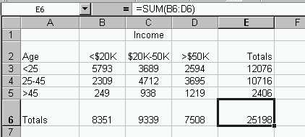
Consider the following events, for a randomly chosen person:
A: {Person is 25 or over }
B: {Person is 45 or under}
C: {Person has income between $20K and $50K}
D: {Person has at least $20K income}

a. Write (complete) Excel formulas that could be entered into a formula bar to calculate:

- $P\left\{A \text{and} B\right\}$.
[5]
= P{(25 or over} and {45 or under)} = P{25 – 45} =E4/E6

- $$P\left\{A|B\right\}\text{.}$$
[5]
= P{A and B} / P{B} =E4/(E3+E4)

- $P\left\{D|A\right\}$.
[5]
= P{D and A} / P{A} =(C4+D4+c5+D5)/(E4+E5)
iv. $P\left\{A \text{or} B\right\}$.
[5]
= P{(25 or over) or (45 or under)} =1

since includes everything

b. One way of finding $P\left\{A \text{or} C\right\}$, is by a sum of table values, divided by the total. Fill out this menu, to calculate the sum needed in the numerator.
[5]
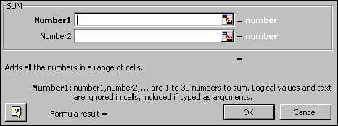
E4:E5 C3

c. Another way to find $P\left\{A \text{or} C\right\}$, is via the “or” rule for probabilities. Write an Excel formula for solving the problem this way.
[5]
= P{A} + P{C} – P{A and C} =((E4+E5+C6-(C4+C5))/E6

- Describe how you would check whether the events $A$ and $D$ are independent or not.
[5]
Show any one of P{A|D} = P{A}, P{D|A} = P{D}

or P{A and D} = P{A} P{D}.

- Are the events $A$ and $B$ mutually exclusive? Why or why not?
[5]
No, P{A and B} is not 0.

