Stat 23, Excel Practice Problems, September 16, 1999

These are intended to illustrate the type of Excel problems that will be on the midterm exam. Most of the problems will be very similar the homework problems.

- A study of CO poisonings yielded the following results in terms of causes and outcomes:
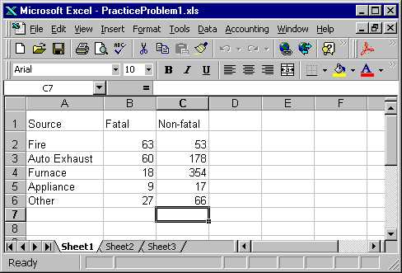

- Write a formula in the formula bar that will make the total of the Non-Fatal cases appear in the highlighted box (Caution: be sure to put the entire formula, including the = sign if it is needed, for full credit).

- Explain the easy way to make the same formula apply for the total of Fatal cases.

Filling in the totals gives:
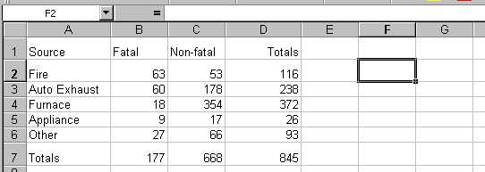

- Write a formula that could be put in the formula bar to calculate the probability that a random case of CO poisoning will:

- Be non-fatal and caused by a furnace.

- Be caused by an appliance.

- Be fatal and not caused by fire.

- Be caused by a fire or be fatal.

- Be caused by a fire, if it turned out not to be fatal.

- One way to solve problem (c) (iv), is by a sum of table values, divided by the total. Fill out this menu, to calculate the sum needed in the numerator:
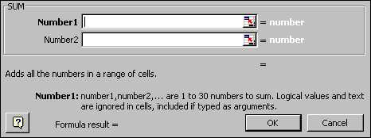

- A supermarket discovered errors in its scanners. Of 376 items checked, 77 were found to have mistakes, of which 65 were overcharges. Suppose a customer purchases 8 items.

- Write a formula that could be used in an Excel formula bar to calculate the probability that a mistake occurs on 4 of the purchased items.

- Write a formula for the probability of at least 4 mistakes.

- Write a formula for the probability of at least 10 mistakes. What will Excel give as an answer? Why?

- Write a formula for the probability of 2 mistakes, if it is known that there are less than 5.

- Write a formula for the probability of either no mistakes, or else more than 3 mistakes.

- Write an Excel formula which gives the chance of an overcharge, on a purchase where an error occurs.

- Fill out this table to calculate the probability of two or fewer overcharges in the 8 purchases:
