Stat 23, Excel Practice Problems 2, November 1, 1999

These are intended to illustrate the type of Excel problems that will be on the second midterm exam. Most of the problems will be very similar to the homework problems.

- which of:

- The Excel data analysis tool “Histogram”
- The Excel function “NORMDIST”
- The Excel function “BINOMDIST”
- The Excel “Chart Wizard”

would be used for:

- Making a histogram of a set of numbers, using bins that Excel chooses?

- Making a histogram of a set of numbers, using your choice of bins?

- Making a probability histogram of the Binomial(35,0.4) distribution?

- Chondrites are rocks that were meteors. To discover how many different sources these were coming from, the percent of silica in the rock was measured. The default histogram in Excel was:
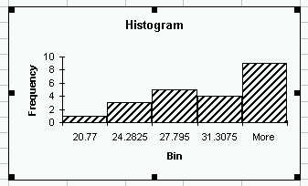

- Comment on this histogram, and indicate how the bins should be changed.

- Comment on the histogram below (for the same set of data), which uses a binwidth of 0.5.
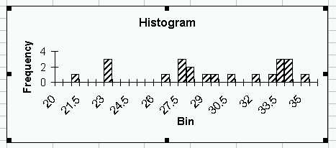

(c) Comment on the histogram below (for the same set of data), which uses a binwidth of 0.5
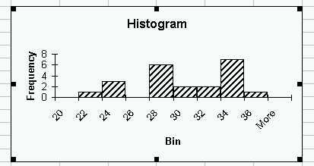

- Some scientists have suggested that these chondrites come from three different sources, which of the histograms in (a), (b) and (c) seem to suggest this?

- For each of these $\text{Bi}(n,p)$ probability histograms, does it look visually like the “Normal approximation to the Binomial will be good or bad?
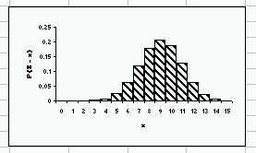
(a)

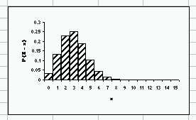
(b)

- Write the Excel commands, you would use, and explain how to interpret the results, to determine whether or not the Normal Approximation will be accurate, for:

- The $\text{Bi}(\text{85},0\text{.}2)$ distribution.

- The $\text{Bi}(\text{92},0\text{.}9)$ distribution.
- For the 5 data points stored in an Excel spreadsheet as: 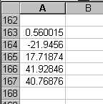, Write a formula that could be used in the Excel formula bar to compute:

- The sample mean.

- The sample standard deviation.

- The sample variance.

- The median.

- Here are some probabilities (computed in Excel) that can be used for finding the median(s) of the $\text{Bi}(\text{100},0\text{.}\text{65})$ distribution:
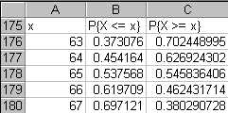

- Use these to find all medians of this distribution.

- Write an Excel formula, that could be used to get the answer in the cell B176.

- How could one guess in advance (without looking at all of them) a reasonable range of these probabilities to display?

- For a standard Normal random variable $Z$, write a formula that could be used in an Excel formula bar, to calculate:

- $P\left\{0\text{.}2≤Z<0\text{.}8\right\}$.

- $P\left\{Z<−3 \text{or} Z>2\right\}$.

- $P\left\{\left|Z\right|≥1\text{.}3\right\}$.

- the number $z_{0}$ so that $0\text{.}\text{34}=P\left\{Z≥z_{0}\right\}$.

- the number $z_{0}$ so that $0\text{.}\text{34}=P\left\{\left|Z\right|≥z_{0}\right\}$.

- For $X \text{\sim } N(−3,7)$, write a formula that could be used in an Excel formula bar, to calculate:

- $P\left\{−1\text{.}2<X<2\text{.}4\right\}$.

- $$P\left\{\left|X+3\right|<0\text{.}5\right\}\text{.}$$

- $$P\left\{\left|X−3\right|<0\text{.}5\right\}$$

- the number $x_{0}$ so that $0\text{.}\text{48}=P\left\{−5<X<x_{0}\right\}$.

IX. For $X\text{\sim }\text{Bi}(\text{70},0\text{.}1)$, write a formula that could be used in an Excel formula bar, to calculate, using the normal approximation to the Binomial:

- $$P\left\{X≥7\right\}\text{.}$$

- $$P\left\{X>7\right\}\text{.}$$

- $P\left\{X>7\text{.}9\right\}$.

- The number $c$ so that $0\text{.}9=P\left\{\left|\frac{X}{\text{70}}−0\text{.}1\right|<c\right\}$.

X. A random sample of 300 observations was taken from a population with unknown mean $μ$ and standard deviation $σ$. The sample mean was 5.7 and the sample variance was 4. Write formulas that could be used in an Excel formula bar to calculate the endpoints of a 99% Confidence interval for $μ$.

