Statistics 23, Section 1, Midterm I
Tuesday, September 21, 1999

Name: _______________________________________________________

Pledge: I have neither given nor received aid on this examination.

Signature: _____________________________________________________

Instructions: Show all work, but do not do hard arithmetic (an answer of the form $\left(\begin{matrix}8 \\ 3\end{matrix}\right)⋅3^{7}$is fine).

- A company makes 50% of its cars at Factory A, 30% at Factory B and the rest at Factory C. Factory A produces 10% lemons, Factory B produces 15% lemons, and Factory C produces 20% lemons. If a car is randomly selected for the overall production system,

- What is the probability that it is a lemon?

- If it turns out to be a lemon, then what is the probability that it was built at Factory C?

- The IRS says about 5 in 1000 tax returns with income below $50,000 are audited, as are 10 in 1000 for income between $50,000 and $99,999, and 25 in 1000 for income $100,000 and more.

- If 10 taxpayers are chosen at random from the high income group, write a (complete) formula that could be used in an Excel formula bar to calculate the probability that:

- Either none, or else at least 4 of them get audited.

- Exactly 2 of them gets audited, if it is known that at least 2 are audited.

- Fill out the Excel menu below to calculate the probability that from a group of 15 taxpayers chosen randomly from the low income group, exactly one of them gets audited.
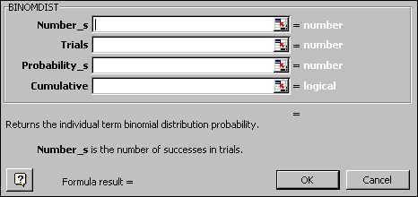

(c) If three taxpayers are randomly selected from the low income groups, and four are selected from the high income group, write a complete Excel formula to calculate the probability that none of these will be audited.

- Suppose events $A$, $B$ and $C$ all have probability 0.6, and $A$ and $B$are mutually exclusive, and $B$ and $C$ are independent.

- Find $P\left\{A \text{or} B\right\}$.

- Find $P\left\{B \text{or} C\right\}$.

4. The random variable $X$ has distribution:
x | 0 | 1 | 2 | 4
f(x) | 0.3 | 0.2 | 0.1 | 0.4

- Find $P\left\{1≤X<4\right\}$.

- Find $P\left\{X=4|X≥2\right\}$.

- Find $P\left\{X=4|X≤2\right\}$.

5 The following table shows the numbers of adults from a small town in age income categories, entered into an Excel spreadsheet, for marketing research purposes.
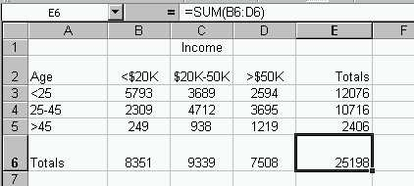
Consider the following events, for a randomly chosen person:
A: {Person is 25 or over }
B: {Person is 45 or under}
C: {Person has income between $20K and $50K}
D: {Person has at least $20K income}

a. Write (complete) Excel formulas that could be entered into a formula bar to calculate:

- $P\left\{A \text{and} B\right\}$.

- $$P\left\{A|B\right\}\text{.}$$

- $P\left\{D|A\right\}$.

iv. $P\left\{A \text{or} B\right\}$.

- One way of finding $P\left\{A \text{or} C\right\}$, is by a sum of table values, divided by the total. Fill out this menu, to calculate the sum needed in the numerator.

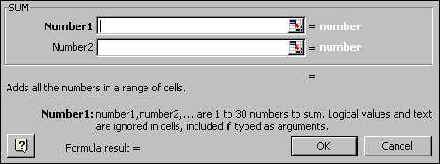

c. Another way to find $P\left\{A \text{or} C\right\}$, is via the “or” rule for probabilities. Write an Excel formula for solving the problem this way.

- Describe how you would check whether the events $A$ and $D$ are independent or not.

- Are the events $A$ and $B$ mutually exclusive? Why or why not?

