Figure 4 distance-phase plot:

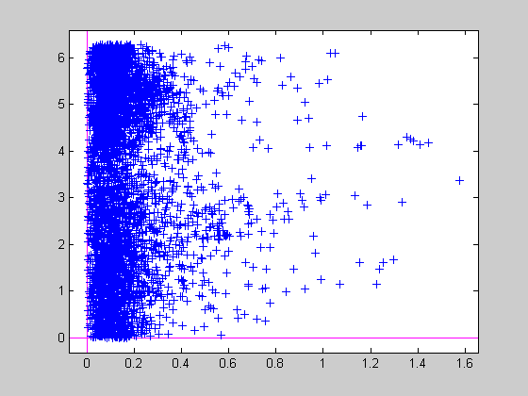

Figure 6 distance-phase plot:

